****

**SIR CHARLES BARRATT MEMORIAL FOUNDATION**

**APPLICATION FOR AWARD**

**MUSIC REPORT FOR**

**2025**

**NAME:**

**Please complete information overleaf:**

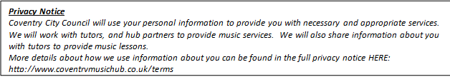**Applicant’s record of musical achievement:**

Dear Instrumental/Vocal Tutor

Text Box

is applying to The Sir Charles Barratt Memorial Foundation for an award.  The Trustees would be grateful for your professional comments in support of the application. **Please give details of any relevant examinations taken. If not applicable, please give approximate standard of the pupil.** This form is specifically for Instrumental/Vocal tutors and should be accompanied by a School Music Teacher and Parent/Carer form.

|  |  |  |  |  |  |
| --- | --- | --- | --- | --- | --- |
| Last Examination taken  Grade       Date | | Instrument | Examination Board | Mark | Award  Fail/Pass/Merit/Distinction |
|  | |  |  |  |  |
|  |  |  |  |  |  |

Please include in your report whether you think your pupil has real enthusiasm and is an active participant in making music with others. Please highlight any ensembles, both in and out of school that they may be involved with. Reference their attitude to developing their own skills and indicate whether they are likely to want to continue their musical education (please feel free to add an extra sheet if necessary).



Performances in which applicant has taken part.

[Text Box]

Name and contact details:

…………………………………………………………….……………………………………………

Signed:

Date:

**Please note the closing date for all applications is Monday 28th April 2025.**