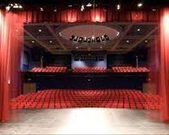A Future in Music?

### Pathways to Careers in Music.

First Steps

Don’t

panic!

Get Motivated

See what’s

out there

Acquire

your skills

The World of Music!

Performers

Composition/ Songwriting

Music Management

Sound Engineering

Music Theatre

Live Events Production

MUSIC

Stage Management

Music Tech



Music Journalism

Music Media

Music Production

 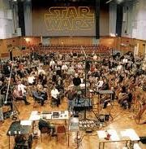

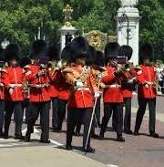Performers.

High level of practical skill = Commitment and practice Performing other peoples work

Careers in studios, freelance musicians, the military services, orchestras, theatres, gigging.



# What Skills Do I Need to be a Performer?



motivation, determination and perseverance

confidence in performing

before an audience

stamina and dedication to continue practising every day

reliability and flexibility as you'll need to work long and irregular hours

the ability to work well as part of a team

creativity

self-discipline and good time management

good communication and interpersonal skills

patience, understanding and resilience, to take on board criticism and accept rejection

attention to detail.

Sound Engineering

* 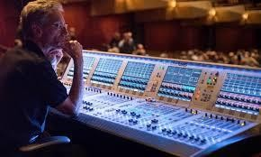Sound engineers use machinery and equipment to record, synchronize, mix, or reproduce music, voices, or sound effects. They work on the **production** of movies, music recordings, live shows, or video games.

What skills do you need

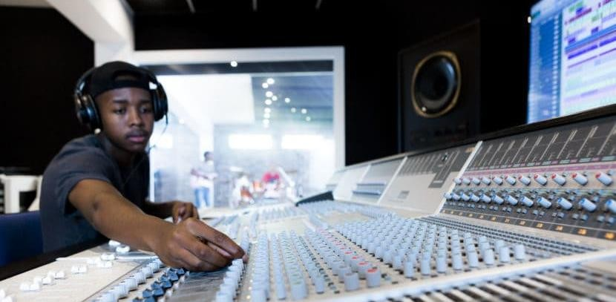

to be a Sound Engineer?

Sound technicians are required in a range of industries including:

Advertising, audio recordings, broadcasting (radio or television),film

You Will Need:

good aural skills

excellent attention to detail

general technical ability, dexterity and agility

the ability to work as part of a team

problem-solving ability

good sense of timing and swift reactions.

and live performance (theatre, music, dance).



Stage Management

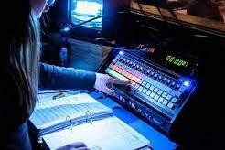**Stage management** requires a general understanding of all aspects of production and offers organisational support to ensure the process runs smoothly and efficiently. A **Stage Manager** supports and organises all the different teams involved in the day-to-day running of a **theatre** or **live event** production from rehearsals right through to performances and then post-show.

They liaise and communicate with the full company and

organise each team to ensure the smooth running of a production.

## Stage Manager. What Skills Do You Need?



* 1. **Organized** ● Stage managers need to know what is being rehearsed and when, who is needed at each rehearsal.● The stage manager keeps everyone on track and on time. ● Stage managers ensure that the necessary rehearsal materials are available when they’re needed.
* 2. **Confident** ● Stage managers are leaders .They need to problem-solve on the fly

and know what to do in an emergency.

* 3. **Assertive** ● Stage managers often must complete slightly awkward tasks such as calling one of their peers or a parent to ask why a cast member isn’t there, or telling a teacher that they have gone over time and need to move on to the next task.
* 4. **Good listener and observer** ● Stage managers must watch and listen carefully to all directions given by artistic staff members and record everything in the stage manager’s prompt book (in pencil, because there WILL be changes). ● This includes entrances, exits, placements of set pieces, props and people, cues for lights, sound effects, music and more.
* 5. **Tactful** ● Being tactful means knowing how to act and respond in delicate or

difficult situations.

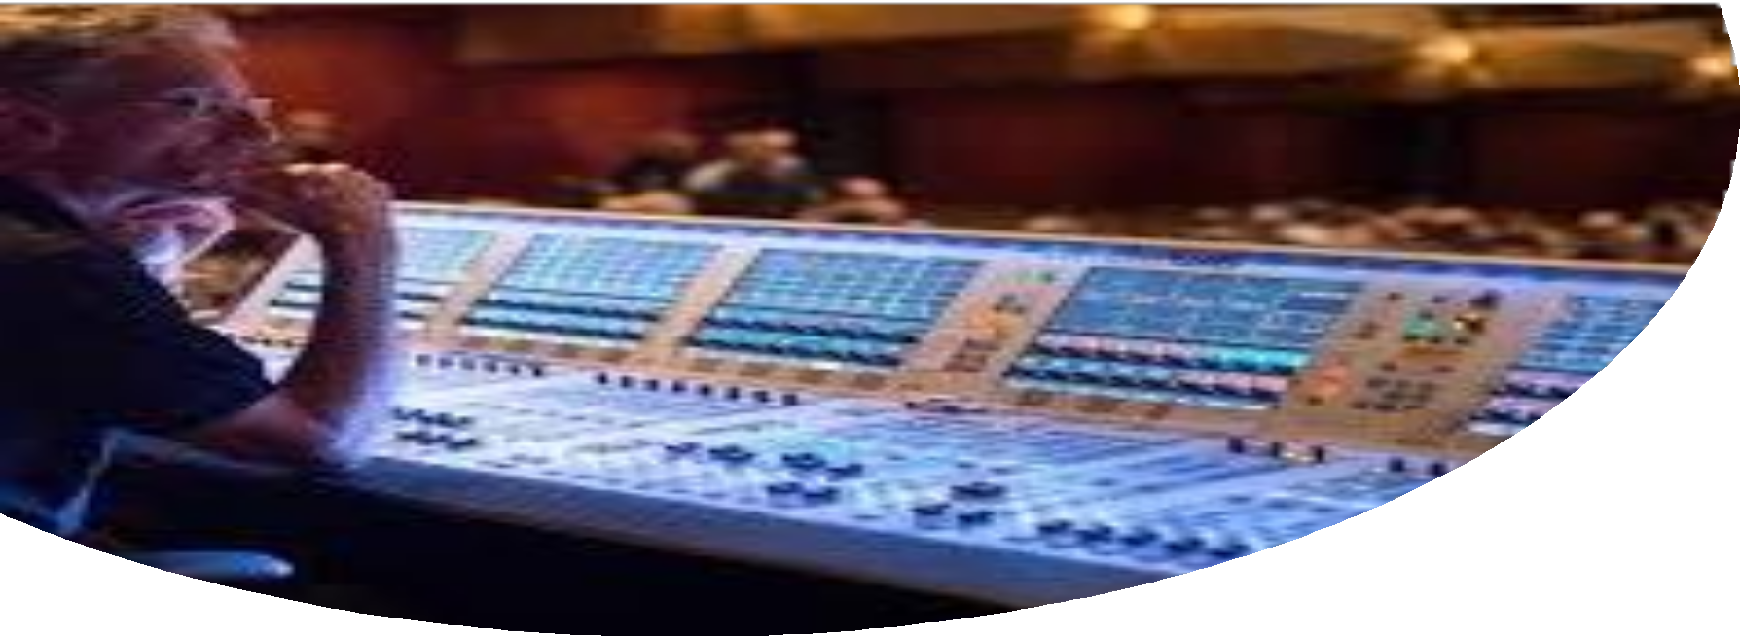

# Live Events Production

* + Career opportunities exist in a huge range of sectors – from live music, festivals and touring to exhibitions, conferences and cruise ships – anywhere a live event takes place!
  + Learn about staging, lighting, sound production and visual production.

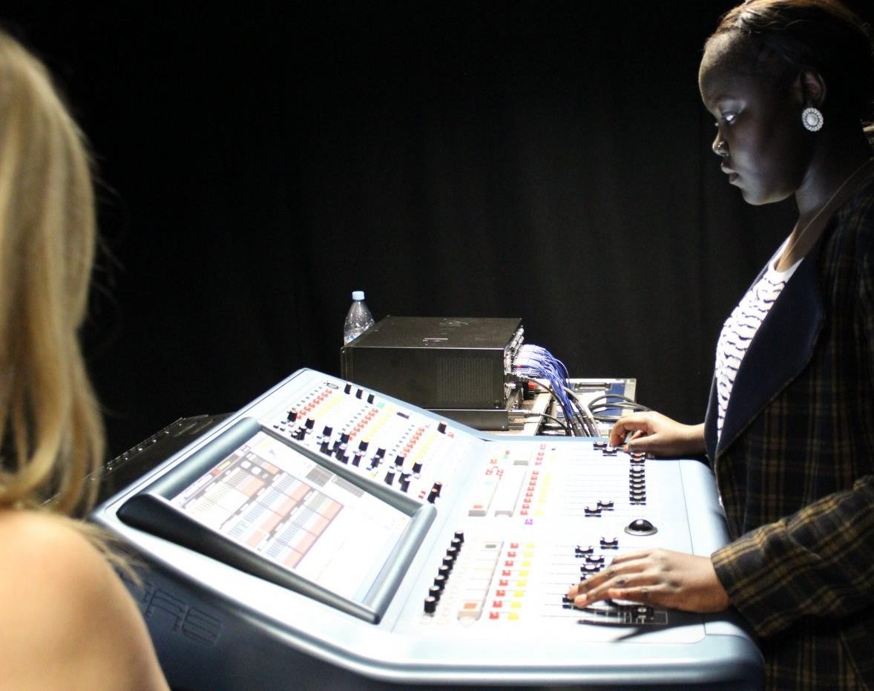

### What skills do you need for Live Events Production?

* Mindset for planning and staging
* Listening and Data Analysis Skills.
* Visualising Skills.
* Design Skills.
* Attention to Detail.
* Speaker Management.
* Responsiveness and Proactivity.



# Music Media

* + Explore the world of digital media and communications, the music business, popular culture, and marketing and PR.
  + You’ll learn about the rapidly growing fields of digital content creation, writing, storytelling skills, journalistic writing, audience engagement, marketing and public relations. Creative entrepreneur, globalisation, self- employment, traditional and digital marketing, creative writing, cultural studies, social media, marketing and PR, app creation and various broadcast skills.

# Skills for Music Media

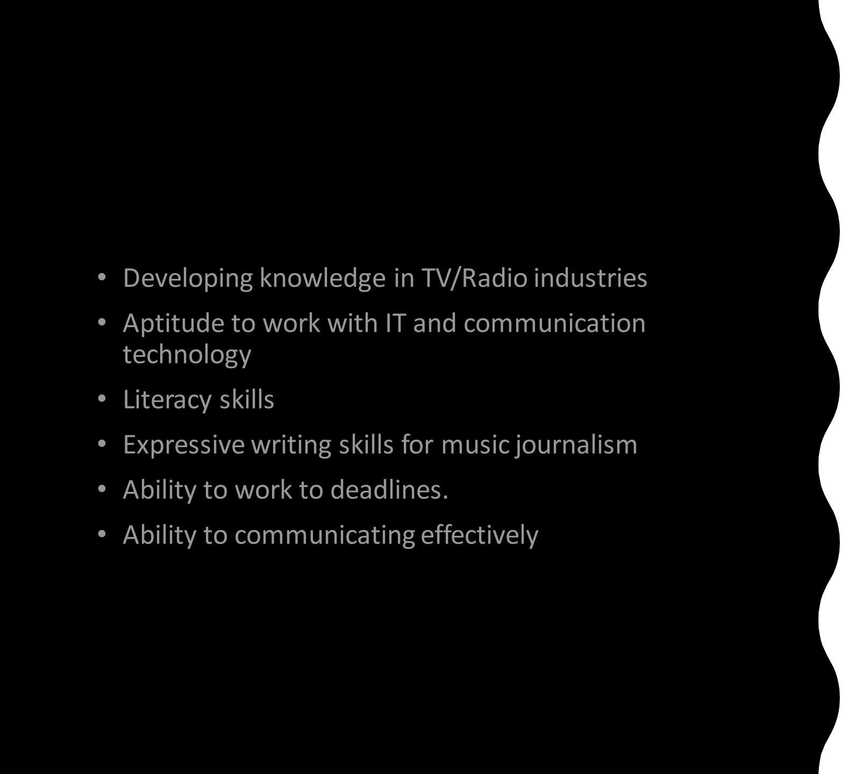

* + - Music management is the work carried out by a music manager (AKA artist manager, band manager or talent manager). A music manager is an individual or company who guides the professional career of artists within the entertainment industry. What Does A Music Manager Do?



* + - Music managers are there to act on behalf of music makers, from artists and bands to producers and songwriters. The manager supports the artists business as well as their creative interests. Ultimately, the music manager is there to guide their artists through any trials and tribulations which may occur.

Music Management

What Skills Do You Need to Become a Music Manager?

Honesty. The ability to



multitask.

Financial literacy.

A DIY spirit to create opportunities for your clients.

Relentless drive.

Some fluency in the artistic language

of **music**.



Connections within the entertainment industry.

A passion for **artist management**.



## Music Therapy

#### Music therapists use music within a therapeutic environment to help individuals of all ages who are experiencing emotional or mental health problems, or who have learning or physical disabilities or physical illnesses.

* Music Therapy is useful for clients who have difficulties with communication or who find it overwhelming to try to express their emotions verbally. Music therapy is not aimed at improving clients’ musical ability.

#### Typical employers of music therapists

* NHS trusts. Local education authorities Local authority social services departments. Hospitals Day or health centres. Residential homes. Nurseries. Special schools Prisons



## Music Therapy Skills

#### Key skills for musical therapists

* + Maturity
  + Empathy and sensitivity
  + Excellent communication skills
  + Musical ability
  + Intuition and creativity
  + The ability to work with people from a variety of backgrounds
  + The ability to deal effectively with challenging situations

Composing

* + - Composers create music for musicians.
    - They can produce work for others or for themselves to perform
    - It covers all musical genres; classical, jazz, rock, pop etc
    - All settings use composers; TV, Radio, Film and IT.
    - Composers in many spaces; concerts halls, recording studios and remotely.
    - Many composers take courses which specialise in developing their composing skills.

What Skills Do You Need To be a Composer?

* + - A good **Composer** is creative, flexible, willing to experiment, collaborate and, most of all, has musical talent. Composers are expected to know how to play at least one instrument and they should be able to carry a tune.
    - Composers apply musical knowledge of rhythm, melody, tone and texture in a variety of ways. They have to be aware of the possibilities and limitations of each instrument, including the human voice.
    - IT software is used by many composers to produce their work.

## Text Description automatically generatedMusic Qualifications.

Degrees.

* You can get a degree in music (BA /BMus) in universities and music colleges and externally via the Open University or similar.
* Military musicians can also access degree courses via the Forces Diplomas.
* These can be taken within a course at a college or university, but can also be taken externally. The Associated Board of the Royal Schools of Music, Trinity Laban College of Music, The London College of Music all provide well respected diplomas that mean you can put letters after your name, such as: ATCL, LTCL, DipABRSM, LRSM, DipLCM, LLCM.
* Qualifications extend right up to Fellowship level for such institutions: FRSM, FTCL, FLCM etc.
* They are excellent professional qualifications for music tutors.

Foundation Courses.

* Many institutions will run Foundation Courses to give you the necessary skills for further study.

Grade Exams.

* Many chose to take Graded exams (eg ABRSM, Trinity Laban, LCM and Rockschool) from beginner to advanced as part of their journey to acquire skills. These can be in performance or theory.

# Apprenticeships and Internships

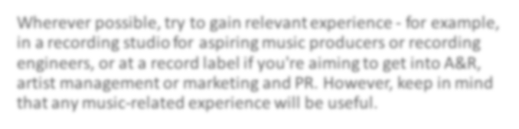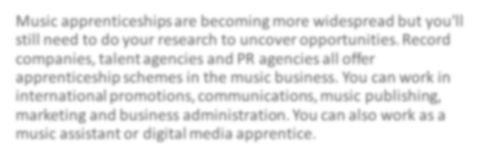

Wherever possible, try to gain relevant experience - for example, in a recording studio for aspiring music producers or recording engineers, or at a record label if you're aiming to get into A&R, artist management or marketing and PR. However, keep in mind that any music-related experience will be useful.

Music apprenticeships are becoming more widespread but you'll still need to do your research to uncover opportunities. Record companies, talent agencies and PR agencies all offer apprenticeship schemes in the music business. You can work in international promotions, communications, music publishing, marketing and business administration. You can also work as a music assistant or digital media apprentice.

# Places to Study Music

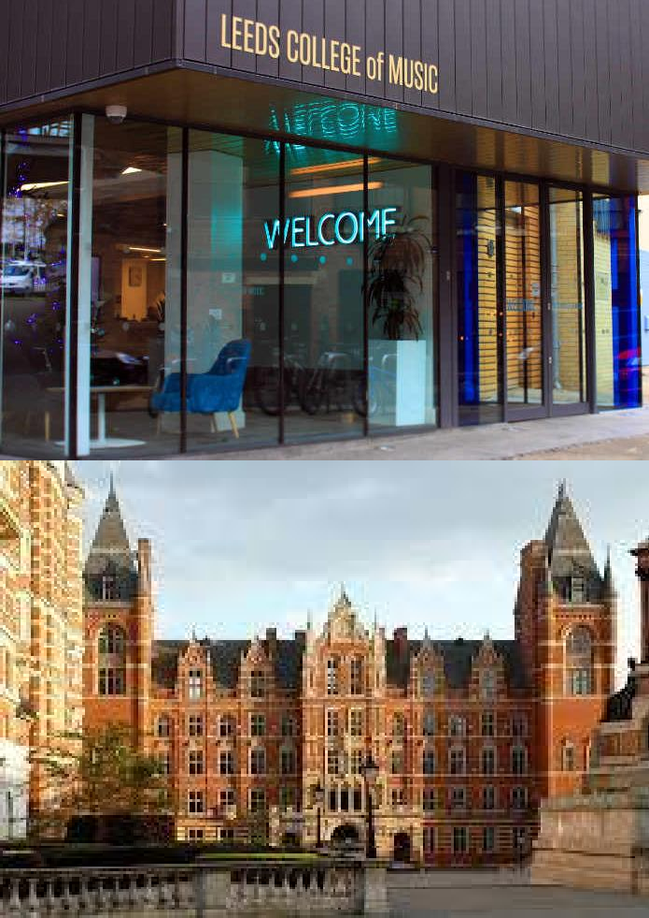

Universities. (eg Durham, West London, Chichester, Southhampton, Oxford/Cambridge etc)

Specialist Music Colleges. (eg Royal Schools of Music, Trinity Laban, Leeds Conservatoire, London College of Music)

Stage and Drama Schools. (eg Guildford, Mountview, Rose Bruford, LIPA, Arts Ed)

Institutions such as BIMM (British and Irish Modern Music)



## Portfolio Career!

* 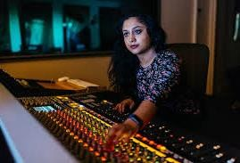Many musicians develop skills across a number of areas in music and develop a ‘Portfolio Career’
* 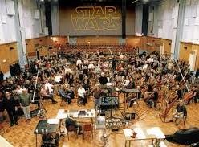Remember that music is a journey for life. Enjoy the trip!!